Internal Meeting
fnukad 11@05@2023
IQAC lfefr ,oa NAAC Creteria 5 ds la;kstdksa ,oa lnL;ksa dh cSBd fnukad 11@05@2023 dks nksigj 12%00 cts vk;ksftr dh xbZA Creteria 5 ds IQAC lnL; }kjk PPT izLrqr fd;k x;kA ftl ij izkpk;Z egksn; ,oa IQAC leUo;d }kjk lq>ko fn, x,A
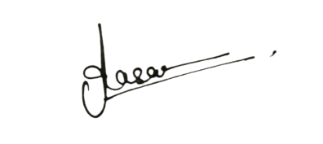
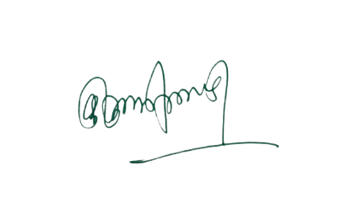

¼MkW-vfurk lkgk½ ¼MkW- ds-,y-VkaMsdj½
IQAC leUo;d Ikzkpk;Z ¼laj{kd½
“kkldh; fnfXot; egkfo|ky; “kkldh; fnfXot; egkfo|ky;
jktukanxkWo¼N-x-½ jktukanxkWo¼N-x-½

